How to Build XP Image for Z390 Dark
1. Use “nLite” Version 1.4.9.3 for XP image support.
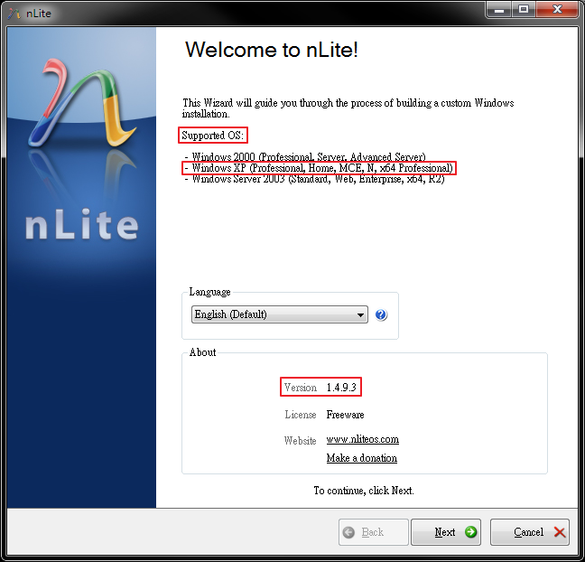

2. Follow the tips to locate a XP installation image.
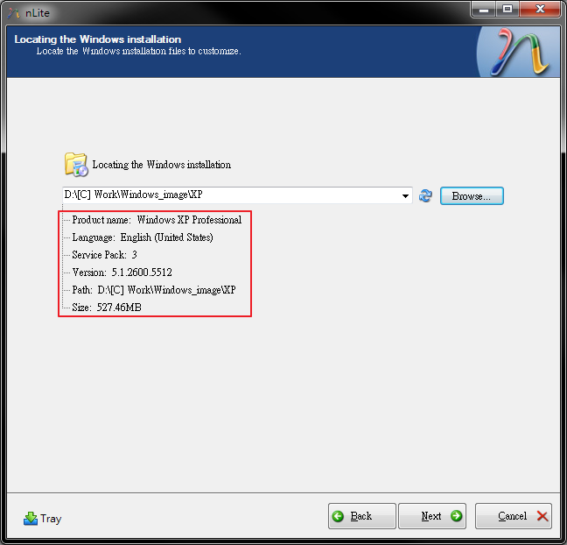
3. Import other or load previous settings. If there is no previous setting, just go next.
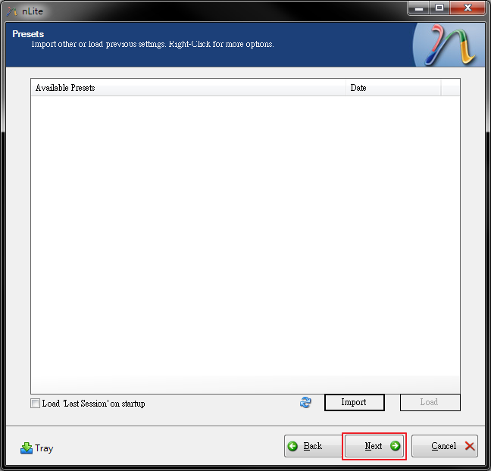

4. Choose the tasks. (Drivers & Bootable ISO)
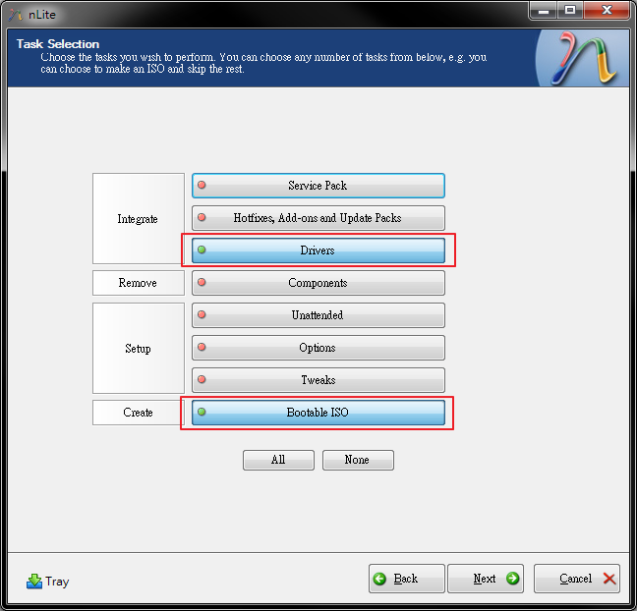

5. Integrate ASMedia SATA driver (Version 2.0.9.0001) into the installation.
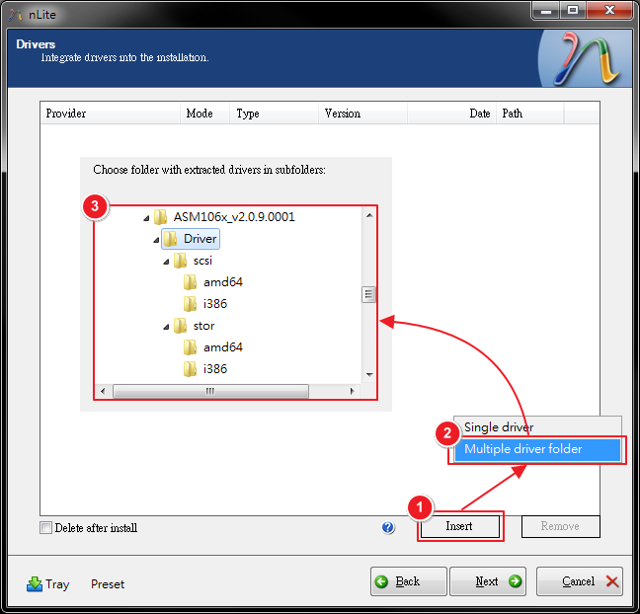

6. Select x86 drivers for XP 32bits.
( Be sure to select only appropriate drivers for your Windows version. For example if you integrate 64bit textmode drivers into 32bit Windows there will be file load error and installation will fail. )
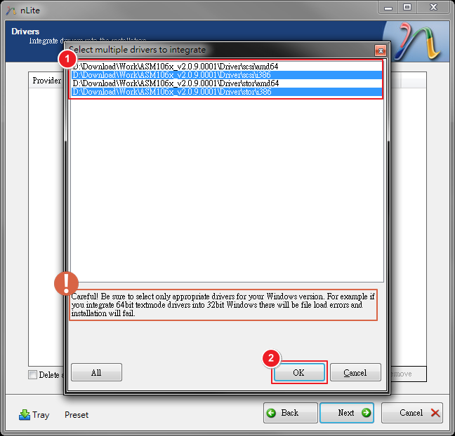
7. Select ASMedia SATA 32bit Textmode driver for XP 32bits.
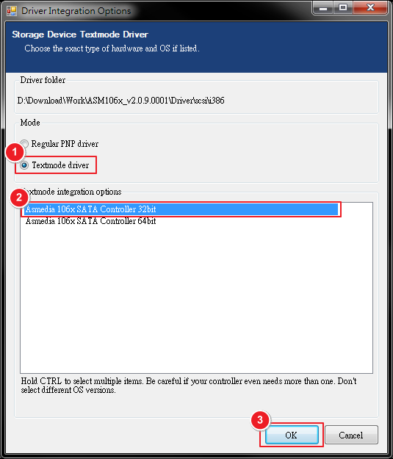

8. Go Next to start the process.
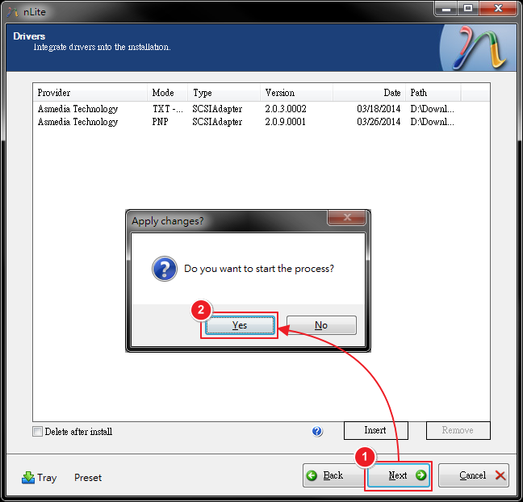

9. Wait for the processing, then go next.
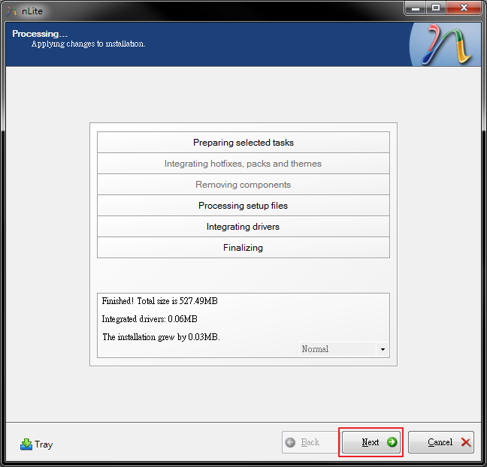

10. Create a bootable XP ISO file and Finished.
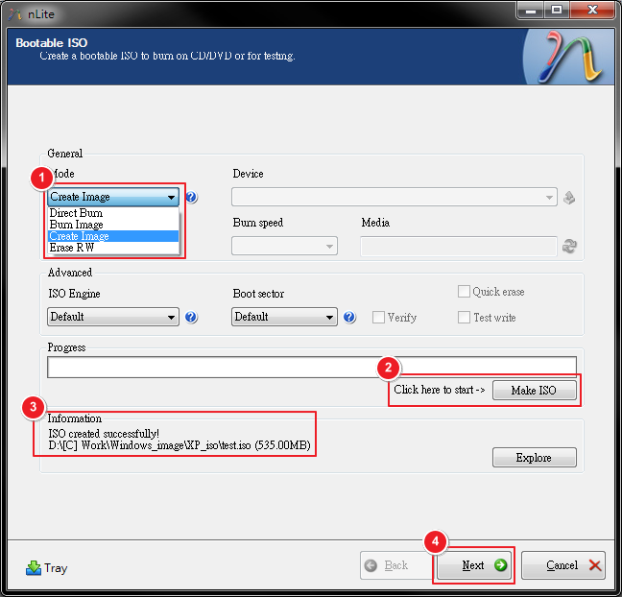

How to Install XP on Z390 Dark
1. Use the following devices to quickly build up XP environment.
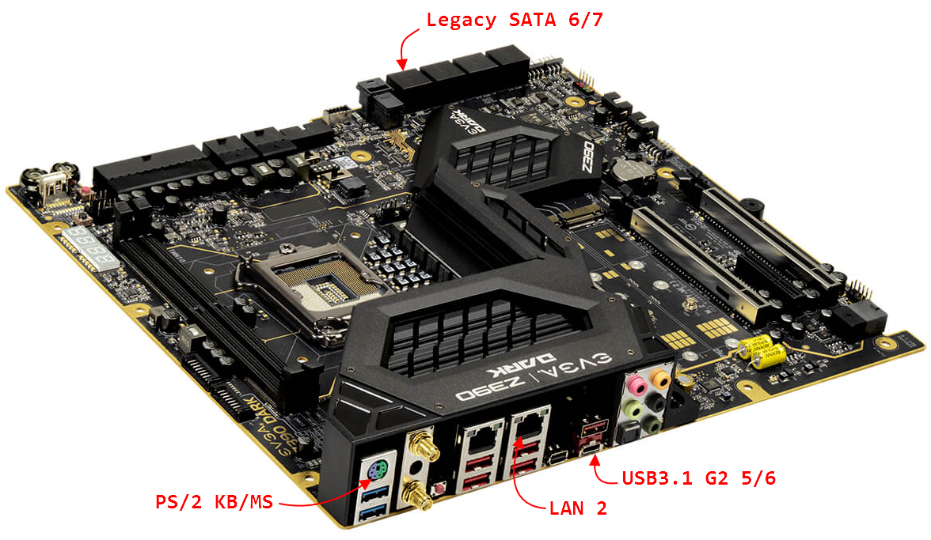

2. Use PS/2 KB/MS and Legacy SATA 6/7 for XP installation.
> PS/2 KB/MS – PS/2 Mouse * 1, PS/2 Keyboard * 1 (with Y-Cable)
> Legacy SATA 6/7 – SATA HDD/SSD * 1, SATA CD/DVD Drive * 1

3. Select LEGACY boot mode in BIOS Boot Page.
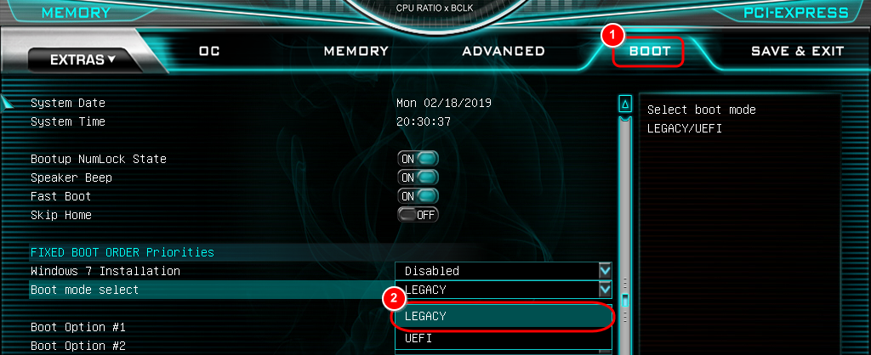

4. Boot from CD/DVD. (Image should including ASMedia SATA 32bit driver)

5. Please wait until the XP installation is complete.
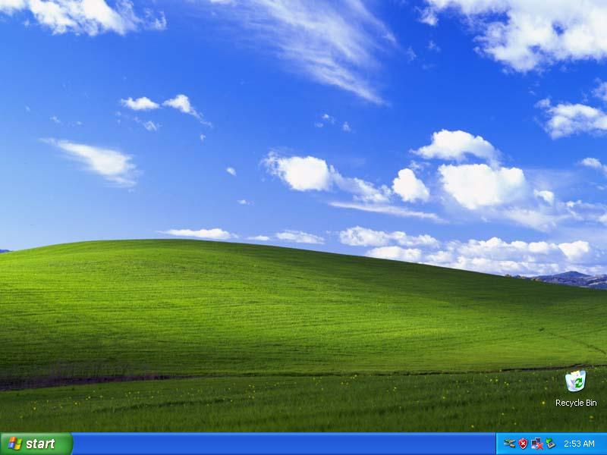

6. To make LAN2 port & USB3.1 G2 5/6 port can be used in XP. (Here is an inconvenient part)
Need to use other OS environments to put the Drivers (for LAN2 port & USB3.1 G2 5/6 port) into XP.
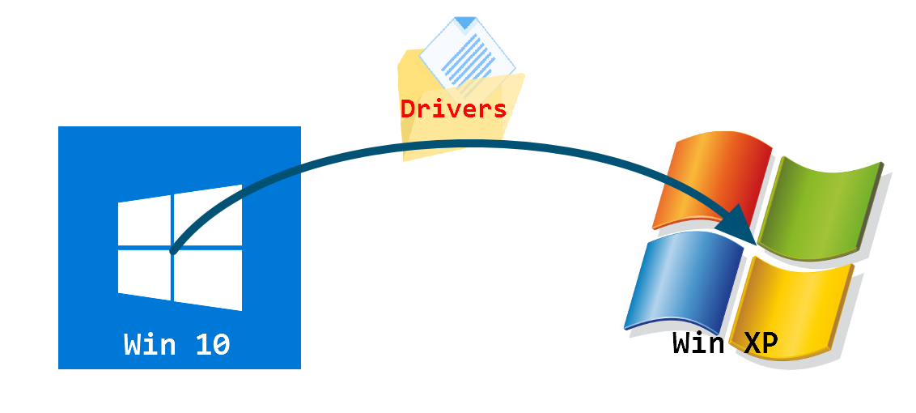
Please refer to the following steps:
> Turn Off system (XP)
> Connect a HDD/SSD with Win10 installed to the motherboard.
> Power On and boot into BIOS Setup.
> Set boot mode to UEFI, Save and Exit.
> Boot into Win10, and put the Drivers into another HDD/SSD with XP installed.
> Turn Off system (Win10)
> Remove the Win10 HDD/SSD from motherboard.
> Power On and boot into BIOS Setup.
> Set boot mode to LEGACY, Save and Exit.
> Back to XP.

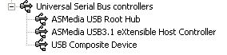
7. Install driver.
> USB3.1 G2 5/6 port (Ver. 1.16.55.1)
- Unzip the file to a designated location or folder.
- Double-Click setup.exe to start the installer
- After driver installed.
- Copy file usbd.sys to C:\WINDOWS\system32\drivers folder.
- After system restart, both USB port should start working.
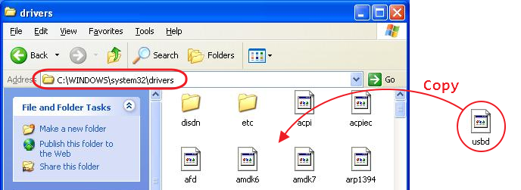

> LAN2 (Ver. 12.3.35.0)
- Unzip the file to a designated location or folder.
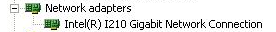
- Open device manager, then select Device Manager.
- Expand the Network interface section.
- Find LAN2 network device. (VEN_8086 / DEV_1533)
- Right-Click the network device and select Update Driver Software.
- Install driver from local disk.
- Browse and select the directory where the driver files are located.
- Drivers are now being installed.
- After system restart, LAN port should start working.

8. DONE！
